# **Personality Prediction Utilizing a Trained Language Model on Social Media**

Parthasarathy G1,Anuraj Bose2,

School of Computer Science and Engineering, VIT, Vellore, India

***anuraj***[***.bose2022@vitstudent.ac.in***](mailto:rachita.batra2022@vitstudent.ac.in)

***Abstract***

Personality is said to be the mix of segments and attributes that make up one’s particular temperament, including thoughts, feelings, and behaviours. In image classification and other higher-level vision tasks, inspired by the success of convolutional neural networks, we explore two applications of such deep convolutional neural networks to model tasks typically involving human assessment, viz. i) prediction of personality from social media images and ii) prediction of citations from the visual elements of an academic paper. The inherent aim of this value context is to determine if there is any predictable and learnable signal in the input data. The ever-bumping social media users have dramatically opened the door to massive gains as far as the volume of online information is concerned. The mature context that these users put in social media can repeatedly provide valuable insights into their psyche (e.g., in terms of forecasting job satisfaction, specific inclinations, as well as the success of professional and romantic bonds and relationships), and getting it without the hassle of taking a ceremonial personality test. Denominate personality prediction, the process of concurrently extracting the digital content into features and mapping it according to a personality model. Owing to its simplicity and proven capability, a well-known personality model, called "the big five personality traits," has more often been adopted in the literature as the de facto standard for personality testing. There are numerous algorithms available for extracting inherent contextualised words from textual data for use in a personality prediction module or system, some of which are based on ensemble models or deep learning. Though useful, existing algorithms such as RNN and LSTM suffer from the named limitations. Firstly, these algorithms take massive time to train the model owing to their consecutive inputs. On the other hand, these algorithms also lack the ability to capture the true (semantic) meaning of words; therefore, the context is slightly lost. To address these limitations, this project develops a new prediction method based on a multi-model deep learning architecture and multiple pre-trained language models such as BERT, RoBERTa, and XLNet as feature extraction methods from social media data sources. Finally, the system takes the decision based on the model to make a prediction out of it. Unlike earlier work that has been introduced so far, which adopts a single social media data source with an open and close vocabulary extraction method, the proposed work uses conglomerate social media data sources, namely Facebook and Twitter, and produces a predictive model for each trait using a bidirectional context feature combined with an extraction method. The occurrence of the proposed work has been encouraging, as it has outperformed similar existing works in the literature. More precisely, the proposed model demonstrates the powerfulness of the introduced method as a promising personality prediction model on the Twitter dataset from a big data point of view.

*Keywords: Personality prediction, Natural language processing, Social media, Deep learning, BERT, Language modele, Big Data, Large Dataset,*

***1.Introduction***

Personality plays a huge role in predicting many individual factors, e.g., as mental and physical health, fitness, and career well-being. Therefore, gaining a deep insight upon a person's personality type is the key to describe. In concurrent years, information growth has proliferated at an accelerating pace with the advent of social media, especially in the form of textual data types. According to the Social Media Trends report published in, there are 3.8 billion active users on social media users of social media in the world as of January 2020, with a projected increase of 9.2% of users each year. Often, people use social media to express themselves on certain issues related to their lives and family well-being—psychology, financial issues, interaction with societies and the environment, as well as politics. In some cases, these expressions can be used to characterize the individual behaviour and personality. There have been a myriad of studies that aim to summarise various aspects of personality research. In fact, earlier studies (e.g. [2, 3, 4, 5, 6, 7]) demonstrate that there is a strong correlation between user personalities and their online behaviour on social media. Some examples of applications that can take advantage of the user's personality information include recruitment systems, personal counselling systems, online marketing, personal recommendation systems, and bank credit scoring systems, to name a few [8,9].

Due to the ingrained ambiguities of natural languages, creating an accurate personality prediction model based on the text that a user posts on social media may be a laborious effort. Natural language processing (NLP) has made great strides in dealing with these difficulties. NLP has so far made it possible for computers to comprehend words or phrases written in human language [10]. In NLP, linguistic notions like parts of speech (nouns, verbs, and adjectives) and grammatical structures are frequently utilised [11]. In addition to part-of-speech and structural grammar, NLP is also able to handle the anaphora and ambiguities that frequently occur in a language by using knowledge representations like a dictionary of words and their meanings, sentence structure, grammar rules, and other information like synonyms [7].

Automatic personality prediction has recently received a lot of attention from NLP academics. References [13] state that personality can be described as a pattern of influence or personality that is used to identify particular individuals. To improve classification accuracy, the current personality prediction system makes use of open vocabulary feature extraction, deep learning, and machine learning algorithms. This method does not fully extract contextual characteristics from sentences due to constraints on computational techniques and the use of a pre-defined corpus. In addition, the small number of datasets used in personality prediction systems, particularly when using deep learning algorithms [8, 14], is the biggest obstacle to maximizing model performance. In order to address the aforementioned problems, this peroject suggests a multi-model deep learning architecture that is built on top of various pre-trained language models, including the Bidirectional Encoder from Transformer (BERT), A Robustly more optimised BERT Pretraining Approach (RoBERTa), and XLNet's Generalized Autoregressive Pretraining for our Language Understanding. Later, the text-based data will be supplemented with more NLP features, such as sentiment analysis, term frequency-inverse gravity moments (TF-IGM), and the National Research Council (NRC) Emotion Lexicon Database, in order to create a multi-model deep learning architecture to predict personality traits. The following is a summary of the contributions made by this work:

* Thus this project demonstrate about Big Data input as a dataset in use.
* This project demonstrate that, in terms of personality trait prediction, this methods outperform those used in the earlier study.
* With pre-trained language models BERT, RoBERTa, and XLNet, as well as additional NLP features (sentiment analysis, TF-IGM, and the NRC emotion lexicon database), this project suggests a multi-model deep learning architecture as a way for extracting features for personality prediction systems.
* In contrast to the other method, we also suggested combining data from various social media sources to increase the number of datasets and improve classification.
* The effectiveness of the developed model is assessed, and it is contrasted with other algorithms from earlier studies that are the most effective in predicting personality.

***2.Literature Survey***

It is not new to anticipate personalities using Facebook and Twitter data in real time. While ago, A Facebook personality dataset called My Personality, which consists of 250 users' status information and personality traits and maps to the Big Five Personality Model, was used in research by [14, 15, 16, and 17]. The most usual technique for extracting features is called Linguistic Inquiry by which the Word Count (LIWC), a linguistic analytical tool that aids in the analysis of quantitative texts and calculates the number of words that have the meaning of categories based on a psychological dictionary in a broadway of this. Meanwhile Another study using the Baasha Twitter dataset that was conducted by [18, 19, 20] used a different technique. This study used the dataset to predict personality traits. Using n-gram and LIWC in feature extraction approaches, the researcher evaluated the user's propensity for word choice. This study also makes use of a close vocabulary approach called Term Frequency-Inverse Document Frequency (TF-IDF) to demonstrate the connection between the primary terms discussed in participants' social media status updates and their personalities. By using this technique, the least significant words in the text are removed, and the sentences' primary subjects are chosen [21].

There are variations, though, in the research done [22], which used a dictionary called Structured Programming for Linguistic Cue Extraction (SPLICE) as a technique for feature extraction. A value for the complexity and readability of a text can be generated by using dictionary features like the speaker's evaluation, which can be positive or negative. The collected features will then be compared between the two methods using deep learning architectures like convolutional neural networks, support vector machines, and linear discriminant analysis (LDA). The accuracy score for the resulting performance, which ranges from 60% to 75%, is still low for a number of personality models. Thus is a result of the study's limited datasets, which were used to create a generalised model that captured much more contextual information.

The use of deep learning, the most recent technology, has been widely used to enhance performance in personality prediction. Similar to the experiment carried out by [23, 24, 25, 26] using a different dataset, namely the personality there are variations in personality modeling, referred to as the Myers-Briggs Type Indicator (MBTI) approach. With a maximum accuracy of 86.9%, the deep learning architectures Long Short-Term Memory (LSTM) and Transformer are capable of producing high-performance MBTI personality modeling. Pre-trained embedding has also begun to be used frequently in research to identify personality traits, with studies [27, 28] developing the Big Five personality model using pre-trained models like BERT and RoBERTa as feature embedding. This study's findings indicate 67% and 60% accuracy. Because there is not enough information in the two investigations, more information is required to further the research. In contrast, using pre-trained models to address other NLP issues like text-based emoticon classification [29] and toxic comment classification [1] with RoBERTa and XLNet shows an increase in accuracy when combined with other NLP features like TF-IDF and sentiment analysis.

In contrast to all of these methods, this project has focused on extracting a person's personality from their interactions on Facebook and Twitter using a combination of deep learning architectures and model averaging. The researcher also added NLP features to the deep learning architecture, which were derived from psycholinguistic and fundamental linguistic features. The domain of BIG DATA and NLP will match together in a hybrid medium of work.

***3.Proposed Solution***

This project will be conducted in three stages, including model building, model assessment, and concentration on leveraging social media data from Facebook and Twitter. Figure 1 depicts the specifics of each stage. To increase the amount of Twitter data already gathered for earlier studies [3,19,27], data collection was done at the beginning stage. To identify each Twitter user's personality, manually collected Twitter data will be annotated with the assistance of a psychologist. The Facebook dataset, on the other hand, will make use of the MyPersonality open-source dataset.

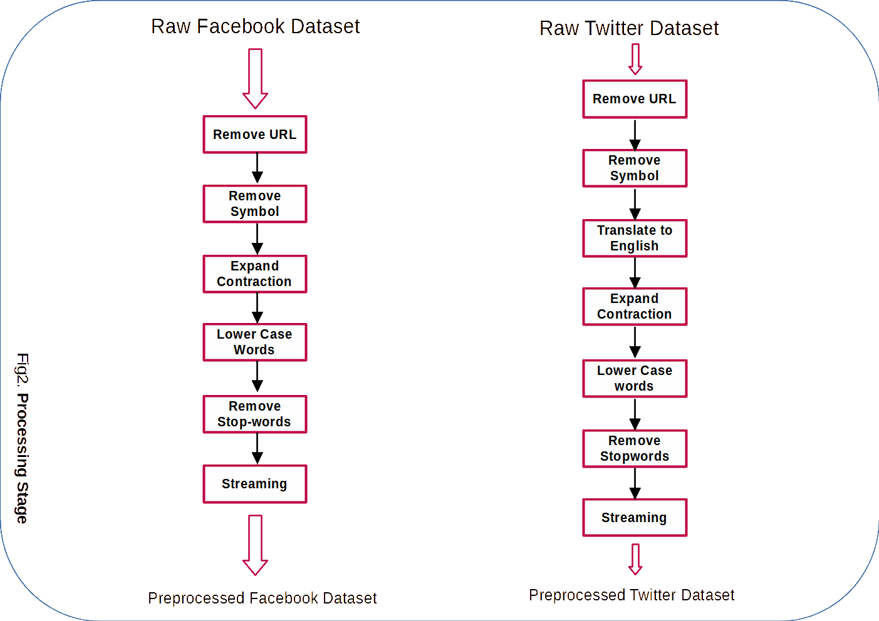

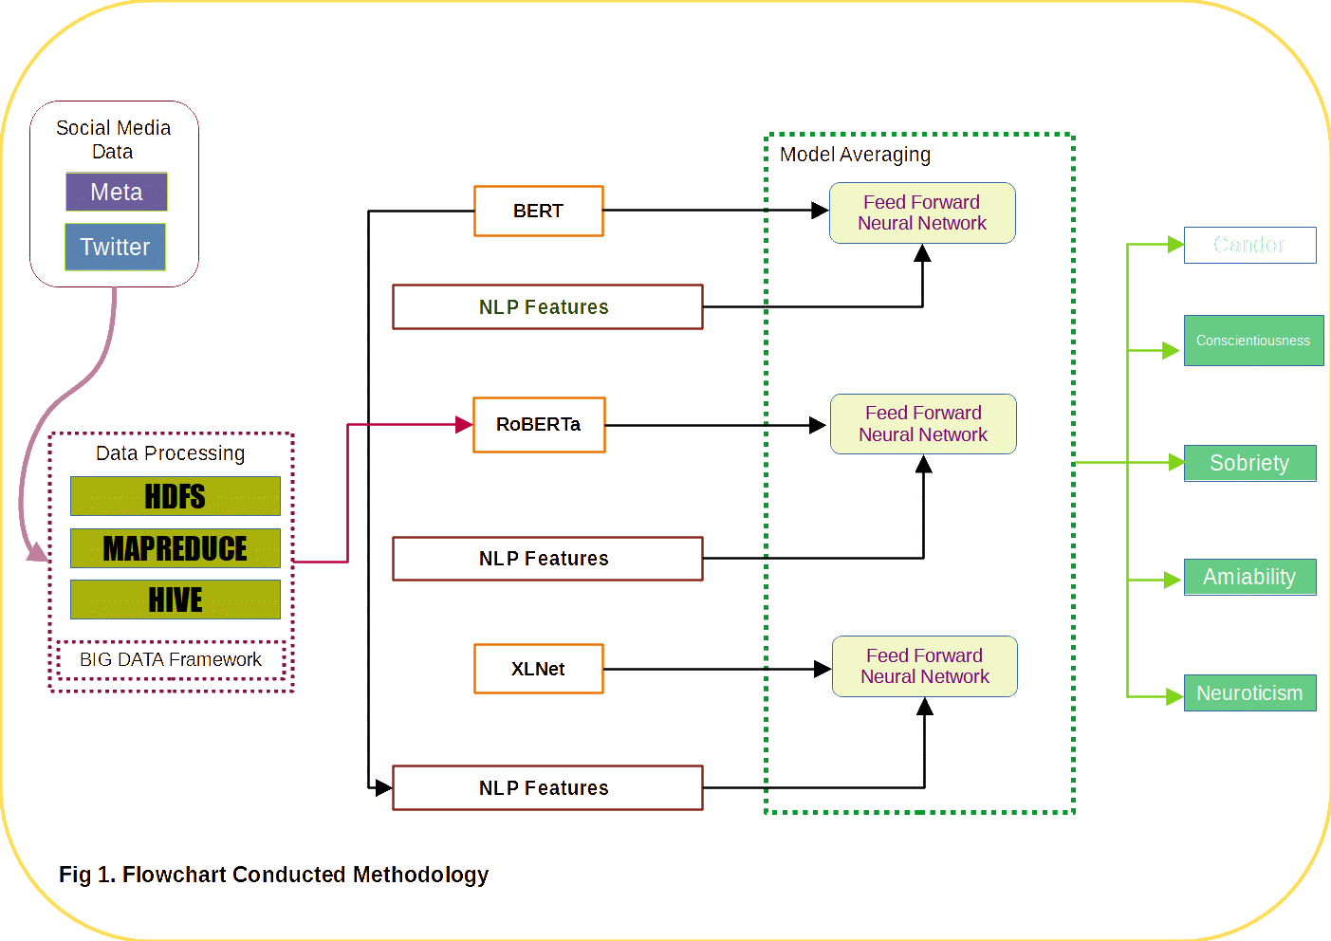

***Preprocessing***

Before feature extraction is done, all datasets will go through preprocessing. Since the Facebook dataset is in English and the Twitter dataset is written in Bahasa, the major goal of preprocessing is to maximise the extracted features. As a result, more contextual features are created, and both datasets are normalised. Fig. 2 depicts the progression of the first procedures for both datasets. The preprocessing for the two datasets is generally the same. The usage of URLs, symbols, and emoticons in social media status updates will be deleted together with all previously gathered data. Next, change an "I've" in the sentence to an "I have" by extending the contraction. Each sentence will then be normalised by being converted to lowercase. In order to avoid ambiguities, stopwords and clitics will also be eliminated. The stemming function will then be used to normalise the words in this list by deleting affixes, ensuring that the final form is a recognised term in a dictionary. The NLTK package, which offers numerous linguistic functions to help clean up social media status data, such as tokenization, stemming, and stop-word dictionary, is used in this preparation. To translate from Bahasa to English, there will be an additional step during the preprocessing of Twitter data. In this study, the process of translating Twitter status data is carried out using the Google Translate API.

***4.Experiment and Results***

***5.Summery & Future Scope:***

***6.Conclusion***

***References***

[1] Acheampong FA, Nunoo-Mensah H, Chen W. Transformer models for text-based emotion detection: a review of BERT-based approaches. Artif Intell Rev. 2021.

<https://doi.org/10.1007/s10462-021-09958-2>

[2] Alam F, Stepanov EA, Riccardi G. Personality traits recognition on social network Facebook. AAAI Workshop—Technical Report, WS-13-01, 2013. pp 6–9.

[3] Cui B (n.d.). Survey analysis of machine learning methods for natural language processing for MBTI Personality Type Prediction.http://cs229.stanford.edu/proj2017/final-reports/5242471.pdf

[4] Han S, Huang H, Tang Y. Knowledge of words: An interpretable approach for personality recognition from social media. Knowl-Based Syst. 2020;194:105550. https://doi.org/10.1016/j.knosys.2020.105550

[5] Howlader P, Pal KK, Cuzzocrea A, Kumar SDM. Predicting facebook-users’ personality based on status and linguistic features via flexible regression analysis techniques. Proc ACM Symposium Appl Comput. 2018. https://doi.org/10.1145/3167132.3167166

[6] Khurana D, Koli A, Khatter K, Singh S. Natural Language Processing : State of The Art ,

Current Trends and Challenges Natural Language Processing : State of The Art , Current Trends and Challenges Department of Computer Science and Engineering Manav Rachna

International University , Faridabad-. ArXiv Preprint ArXiv, August 2017. 2018.

[7] Kircaburun K, Alhabash S, Tosuntaş ŞB, Griffiths MD. Uses and gratifications of problematic social media use among university students: a simultaneous examination of the big five of personality traits, social media platforms, and social media use motives. Int J Ment Heal Addict. 2020;18(3):525–47. https://doi.org/10.1007/s11469-018-9940-6

[8] Aung ZMM, Myint PH. Personality prediction based on content of facebook users: a

literature review. Proceedings - 20th IEEE/ACIS International Conference on Software Engineering, Artificial Intelligence, Networking and Parallel/Distributed Computing, SNPD

2019; 2019. pp. 34–38. https://doi.org/10.1109/SNPD.2019.8935692

[9] Dandannavar PS, Mangalwede SR, Kulkarni PM. Social media text—a source for personality prediction. Proc Int Conference Comput Tech Electronics Mech Syst CTEMS.

2018;2018:62–5. https://doi.org/10.1109/CTEMS.2018.8769304

[10] Ben-Porat O, Hirsch S, Kuchy L, Elad G, Reichart R, Tennenholtz M. Predicting strategic behavior from free text. J Artif Intell Res. 2020;68:413–45

<https://doi.org/10.1613/JAIR.1.11849>

[11] Redhu S. Sentiment analysis using text mining: a review. Int J Data Sci Technol. 2018;4(2):49. <https://doi.org/10.11648/j.ijdst.20180402.12>

[12] Redhu S. Sentiment analysis using text mining: a review. Int J Data Sci Technol. 2018;4(2):49. <https://doi.org/10.11648/j.ijdst.20180402.12>\

[13] Marouf AA, Hasan MK, Mahmud H. Comparative analysis of feature selection algorithms for computational personality prediction from social media. IEEE Trans Comput Social Syst.

2020;7(3):587–99. <https://doi.org/10.1109/TCSS.2020.2966910>

[14] Howlader P, Pal KK, Cuzzocrea A, Kumar SDM. Predicting facebook-users’ personality based on status and linguistic features via flexible regression analysis techniques. Proc ACM Symposium Appl Comput. 2018. https://doi.org/10.1145/3167132.3167166

[15] Tandera T, Hendro S, D., Wongso, R., & Prasetio, Y. L. . Personality prediction system from facebook users. Procedia Comp Sci. 2017;116:604–11.

https://doi.org/10.1016/j.procs.2017.10.016

[16] Vaswani A, Shazeer N, Parmar N, Uszkoreit J, Jones L, Gomez AN, Kaiser Ł, Polosukhin I. Attention is all you need. Advances in Neural Information Processing Systems, 2017 Decem(Nips), 2017. pp. 5999–6009.

[17] Yang Z, Dai Z, Yang Y, Carbonell J, Salakhutdinov R, Le QV. XLNet: generalized autoregressive pretraining for language understanding. ArXiv, NeurIPS; 2019. pp. 1–18.

[18] Adi GYNN, Tandio MH, Ong V, Suhartono D. Optimization for automatic personality recognition on Twitter in Bahasa Indonesia. Procedia Comp Sci. 2018;135:473–80. <https://doi.org/10.1016/j.procs.2018.08.199>

[19] Jeremy NH, Prasetyo C, Suhartono D. Identifying personality traits for Indonesian user from twitter dataset. Int J Fuzzy Logic Intell Syst. 2019;19(4):283–9. https://doi.org/10.5391/IJFIS.2019.19.4.283

[20] Ong V, Rahmanto ADS, Williem W, Suhartono D, Nugroho AE, Andangsari EW, Suprayogi MN. Personality prediction based on Twitter information in Bahasa Indonesia. Proceedings of the 2017 Federated Conference on Computer Science and Information Systems,

FedCSIS 2017, 11; 2017. pp. 367–372. https://doi.org/10.15439/2017F359

[21] Christian H, Agus MP, Suhartono D. Single document automatic text summarization using term frequency inverse document frequency (TF-IDF). ComTech Comp Math Eng Appl. 2016;7(4):285 https://doi.org/10.21512/comtech.v7i4.3746

[22] Lim HS, Bouchacourt L, Brown-Devlin N. Nonprofit organization advertising on social media: the role of personality, advertizing appeals, and bandwagon effects. J Consumer Behav. 2020. https://doi.org/10.1002/cb.1898

[23] Cui B (n.d.). Survey analysis of machine learning methods for natural language processing for MBTI Personality Type Prediction.

http://cs229.stanford.edu/proj2017/final-reports/5242471.pdf

[24] Hernandez and Knight. (n.d.). Predicting MBTI from text.

[25] Keh SS, Cheng I-T. Myers-Briggs personality classification and personality-specific language generation using pre trained language models. July. 2019.

http://arxiv.org/abs/1907.06333

[26] Yuan C, Wu J, Li H, Wang L. Personality recognition based on user generated content. 2018 15th International Conference on Service Systems and Service Management, ICSSSM 2018; 2018. pp. 1–6. https://doi.org/10.1109/ICSSSM.2018.8465006

[27] Jiang H, Zhang X, Choi JD. Automatic text-based personality recognition on monologues and multiparty dialogues using attentive networks and contextual embeddings. ArXiv, 2019. pp. 2–4.

[28] Kazameini A, Fatehi S, Mehta Y, Eetemadi S, Cambria E, Computational G, Unit N. Personality Trait Detection Using Bagged SVM over BERT Word Embedding Ensembles. 2020. pp. 1–4.

[29] Maslej-kreš V, Sarnovský M, Butka P. Comparison of deep learning models and various text pre-processing techniques for the toxic comments classification. Appl Sci. 2020. <https://doi.org/10.3390/app10238631>